# Data Flow Diagram &User Stories

|  |  |
| --- | --- |
| **Date** | **03 October 2022** |
| Team ID | PNT2022TMID47584 |
| Project Name | Skills and job recommended |
| Maximum Marks | 4Marks |

## Data flow diagram:

A data flow diagram is a graphical or visual representation using a standardized set of symbols and notations to describe a business's operations through data movement. They are often elements of a formal methodology such as structured Systems Analysis and Design Method .

# ROUGH DIAGRAM

## DIAGRAM:

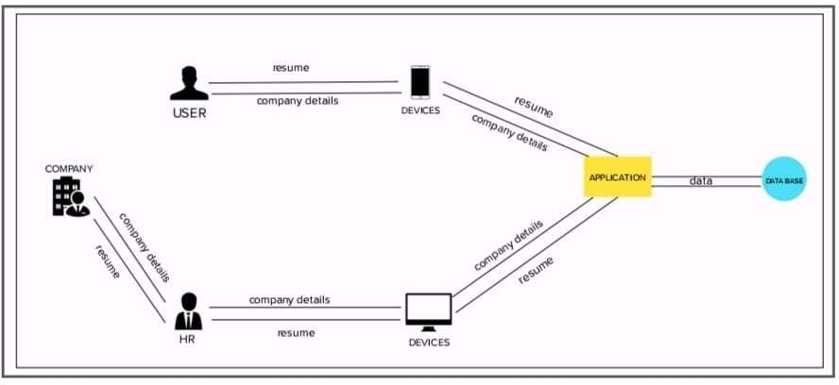

|  |  |  |  |  |  |  |
| --- | --- | --- | --- | --- | --- | --- |
| **User Type** | **Functional**  **Requirement (Epic)** | **User Story Number** | **User Story / Task** | **Acceptance criteria** | **priority** | **Release** |
| Customer  (Mobile user) | Registration | USN-1 | I give my data like my name , address , email and password to register as a job seeker | I can create my id to  get my dream job | High | Sprint-1 |
| Customer (company ) | Registration | USN-2 | I give a data about my company like company name,  address ,certificate and  password to register | I can create my id to get a best and talented workers | High | Sprint-1 |
| Customer  (Mobile user) | Confirmation | USN-3 | I well receive the confirmation mail from the application | I can receive mail for confirmation and then find a job | High | Sprint-1 |
| Customer (company ) | Confirmation | USN-4 | I will receive the confirmation mail after the application completely analiyse the certificate | I can receive confirmation mail and then find the worker | High | Sprint-2 |
| Customer  (Mobile user) | Login | USN-5 | I can login by entering my full name or email and password | I can access my  account after login | Medium | Sprint-1 |